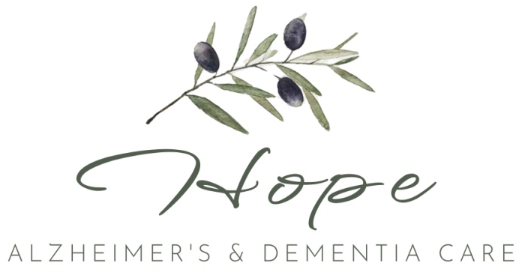

Sponsor a Senior Program

Dear Friend of HOPE,

I want to personally thank you for your interest in supporting our mission at HOPE Alzheimer’s & Dementia Care. As you may know, we provide a loving, person-centered Social Adult Day Program for individuals living with Alzheimer’s and dementia right here in our community. Our days are filled with therapeutic activities, meaningful engagement, enriching community experiences, nutritious meals, and heart-centered support—offered in a safe, home-like environment where every guest is treated with dignity and compassion.
We are excited to introduce our Sponsor a Senior Program, and we’re reaching out to compassionate individuals like you to help us continue this important work. Through this program, you have the opportunity to make a meaningful impact in the life of a local senior and their family by helping them access much-needed respite and care.
While any donation amount is a true blessing and deeply appreciated, we do want to share that our minimum cost to provide five hours of care for one senior for one day is $225. This includes personalized support, activity supplies, meals, transportation, and staffing to ensure safety and comfort. Every contribution—no matter the size—helps us lift the burden from caregivers and creates a space of joy, purpose, and peace for those we serve.
We believe that no senior should go without the care and connection they deserve simply due to financial hardship. Your support will directly touch the lives of our guests and the families who love them. Together, we can provide moments of happiness, comfort, and hope where they are needed most.
If you feel called to sponsor a senior or make a contribution to this heartwarming initiative, please kindly fill out our donation form and/or contact us at (530) 592-9083 with any questions.
From all of us at HOPE, thank you for believing in our mission. Your kindness makes a world of difference.
With gratitude,
Jessica Bernhardt, CEO, RN, CDP
Founder, HOPE Alzheimer’s & Dementia Care
Sponsor a Senior Donation Form
Thank you for your generosity and for making a lasting difference in the life of a senior. Once we receive your donation, we will thoughtfully connect you with the family you are supporting by sharing a brief story and photo, so you can see the heart behind your gift. We believe in making this experience as personal and meaningful as possible for you and for the loved ones you're helping. Your kindness touches more than just one life, it creates ripples of hope throughout our entire community.

Please complete the form below and return to:
HOPE Alzheimer’s & Dementia Care
Attention: Jessica Bernhardt, CEO
1272 Arch Way
Chico, CA 95973

Donor Information:

Name: _________________________________________________________________________
Business/Organization (if applicable): _________________________________________________
Address: ________________________________________________________________________
City/State/ZIP: ___________________________________________________________________
Phone: _________________________________________________________________________
Email: __________________________________________________________________________

Donation Details:
☐ I would like to sponsor a senior for 1 full day ($225)
☐ I would like to sponsor a senior monthly ($225 x ___ months)
☐ I would like to donate a custom amount: $ _______________
☐ This donation is in honor of / in memory of: _________________________________________

Payment Method:
☐ Check enclosed (payable to HOPE Alzheimer’s & Dementia Care)
☐ Please contact me to arrange a credit card or online payment

Would you prefer to remain anonymous?
We fully respect your privacy and understand the importance of discretion. However, with your permission, we would be honored to share your generosity as part of the story of how our community is supporting individuals living with dementia and their families. If you select “No,” we may highlight your contribution—without sharing sensitive details—as a way to celebrate the meaningful difference you are making. ☐ Yes ☐ No

Please note that HOPE Alzheimer’s & Dementia Care is a for-profit social adult day program. While donations made to our Sponsor a Senior Program are not tax-deductible, your contribution goes directly and immediately toward care for individuals in need. Supporting a for-profit care model means you're investing in a locally owned, hands-on program that reinvests every dollar into staffing, daily enrichment, nutritious meals, and meaningful community outings. Your donation helps sustain high-quality, person-centered care right here in Butte County—and every gift, regardless of tax status, has the power to change a life.

Thank you!

